It’s a Mine that is mine

Group Name: The Creators

By: Alisa Ordina

Email: alisa.ordina@georgebrown.ca

ID: 100967526

Milestone One: Game Design Documentation

Game Name: Mine Mine

Table of Contents

1. High level description of the game 2

The idea behind this game

Genre

Category

The game’s Platform

Play Mechanics

Technology

The key features of this game

The game Structure

Part One: The entrance to the Grr’s mine

Part Two: The level two of the game and the mine quest

Obstacles in the game

Level Walkthrough

Game Play Controller Configurations

The damages on the main character

1. Layout of all the game’s screens 6

Scene One

Scene Two

Scene Three

1. UI Flow diagram of how the screens connect with one another 8
2. All assets for your game 9
3. Backstory of the game 12

Mine Mine

1. Game Mechanics 13

# High level description of the game

## The idea behind this game

Grondee (Grr for short) is an Dwarf character. He just inherited his grandpa’s old mine, it grows some of the richest minerals in the world, but it also has some difficult traps of all. The deeper the main character goes, the better the minerals, the worse the traps. His mine has the highest quality minerals in the realm. You play this game from the perspective of Grr the Dwarf character as he goes past dangerous obstacles, around puzzling traps and through ugly enemies.

## Genre

Casual puzzle platformer.

## Category

Grr the Dwarf faces new obstacles along with the mine’s challenging puzzles, which means this is a new experience to this main character. The points are gained through the solving puzzles and gathering golden items and minerals and avoiding getting hurt by the enemies and the mine’s traps.

## The game’s Platform

Since, I am using the Unity’s IDE and its set for windows operating system, this game is designed for Windows based platform. This game is designed in Unity for the Windows/PC platform based.

## Play Mechanics

The user will control the Grr, it is defined as the user’s avatar, as he challenges himself through his magical mine quest. They Key component of this game play are the interaction between Grr and the mine’s enemies, puzzles and traps. The user will use the keyboard as the input device.

* The Main Gameplay Screen - This game includes a main game play screen that includes the main character Grr and his mine.
* UI (Heads Up Display) – The UI screen displays the Grr’s Health points and its Score points during the game play. The Gave Over UI screen is displayed when the main Character’s life has been depleted.

## Technology

This is a 2D game which uses the 2DBox graphics in Unity IDE engine. The 2D Unity games are known for making games in multiple platforms. However, this game is only for Windows PC.

## The key features of this game

In this puzzle platformer has several features which makes it fun, and thought-provoking experience.

* Puzzles, that the main character goes through are thought-provoking and interactive puzzles that the main character must physically solve them to move on further into the mine.
* Story idea, the setting takes place in ancient times where such cultures exist.
* Ability for the player to make meaningful choices in the game to complete the quest. For example, from this previous game play of this game the user knows already where the explosive platform exists and must make a meaningful/logical choice where to proceed next.

## The game Structure

Ideally this game should consist with 2 levels with more being added in the future as needed. The illustrated in activity diagram below shows a template on how the levels should progress. Within each diagram the structure is broken down into the major activities the user needs to beat the quest or the level in this game.

## Part One: The entrance to the Grr’s mine

The first level is the easiest to get through and consist of a few platforms and 1 enemy who does not move from his platform. The user will simple jump from platform to platform to collect coins and finally the mineral stunning or avoiding the monster in the way. The user must make it back to the entrance of the level with the mineral to win the level.

**Figure One:** Activity diagram for getting further into the mine and getting to another level of this game.

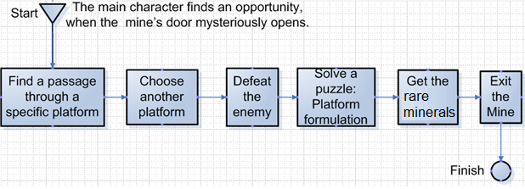

## Part Two: The level two of the game and the mine quest

This level is basically the same as the first, just with a few more monsters and a few more platforms. There will also be a timer that the user must beat to gain extra points.

**Figure Two:** Activity diagram for getting further into the mine and winning this game

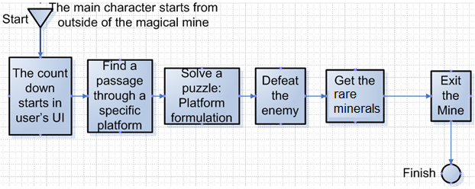

## Obstacles in the game

The main character must go through many obstacles to win this game. These obstacles include enemies, exploding platform and puzzles that are listed in the following table.

| Obstacle/enemy | Description |
| --- | --- |
| Black monster | This is unhuman enemy that the main character must defeat to avoid its attack and not to get life point deducted. |
| Platforms | Some platforms are dangerous traps, and are equipped with explosive devices. When the main character comes in contact, the platform with flash briefly before exploding. |
| Gold Item | An item that the main character could collect to gain points. |
| Rear mineral | An item, that the main character desires to collect as many as possible. Only one in each level. |

## Level Walkthrough

Ideally this game should consist one major area of the game that is the Grr’s mine which is described below and what the main player encounters in the game.

| Category | Description |
| --- | --- |
| Area of the Mine | This is the main area of the game where the user will move the character around the mine solving puzzles and beating enemies. As the game progresses the puzzles that the player must solve will become more complex and the enemies will become more numerous and harder to deal with. New puzzle elements will be added in as the levels increase to enhance the complexity of the puzzles. |
| Key Objects | rare minerals, and golden pieces. Beating levels within the timer. |
| Unique things about the mine’s surroundings. | The mine is relatively dark and has its platforms arranged in a path that leads to the lowest portions of the level. At times these platforms will contain the black monsters sliding through the or puzzles to solve. The platform arrangement may also be the puzzle. |
| Mood/Tone | The mood should be creepy and dark, the mine itself should feel dilapidated or unkept. Sounds like the cave is with the dripping water. The dark monsters should make echoing shuffling sounds. |
| Major Character | The Grr the Dwarf who owns the mine. |
| The second level of this game | The second level of this game is similar except it has a countdown timer attached to this game. The main player must finish the retrieval of the rear mineral items before the countdown runs out. |

## Game Play Controller Configurations

| Control Category | Key | Action |
| --- | --- | --- |
| The main character’s action: The main player’s up direction | Key: W | When the main player need to go in the upper direction or jump, the keyboard’s W key should be pressed. |
| The main character’s action: The main player’s left direction | Key: A | When the main player need to go in the left direction the keyboard’s A key is pressed. |
| The main character’s action: The main player’s down direction | Key: S | When the main player need to go down the keyboard’s S key is pressed. |
| The main character’s action: The main player’s right direction | Key: D | When the main player need to go in the right direction the keyboard’s D key is pressed. |
| The main character’s action interaction with the enemy: The main player’s fire | Key: Space | When the main player need to fire at the enemy the space bar is pressed. |

## The damages on the main character

The main character could encounter a form of damage or penalty such as exploding platform. The table below summarizes some of the main character’s damages that effect the main player in the game play.

| Effect Category | Description |
| --- | --- |
| Health | This game play has a health counter that tracks the main player’s life. Anything that causes damage will decrease the health counter. |
| Damage | Enemies and dangerous platforms cause damage when they touch the main character. |
| Main character’s death | When the health counter reaches zero the main character ‘dies’. The user can then choose to restart the level or end the game. |

# Layout of all the game’s screens

## Scene One

The first scene starts with the main character named Grr at the start of the mine’s path. Where the time will be started.

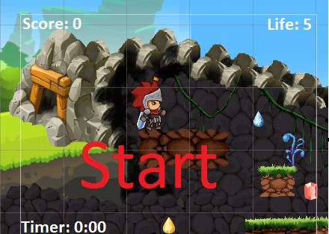

## Scene Two

The second screen layout shows the platform traps, the next scene layout shows the encounter with the enemy, and the main player’s attack.

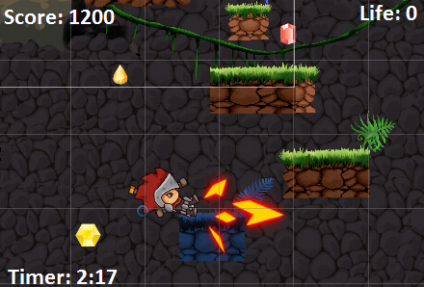

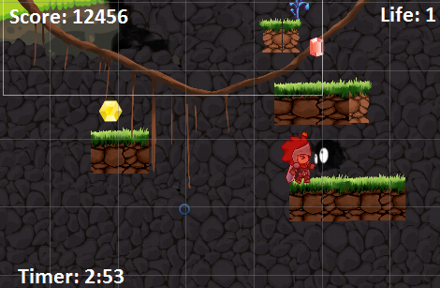

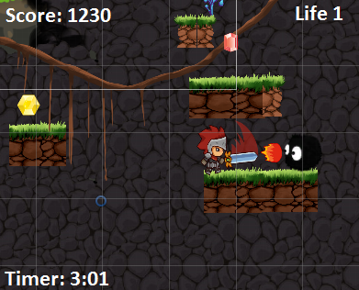

## Scene Three

The appropriate Heads Up Display, UI is displayed when the main’s player life is depleted.

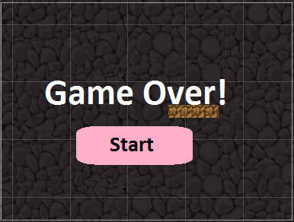

# UI Flow diagram of how the screens connect with one another

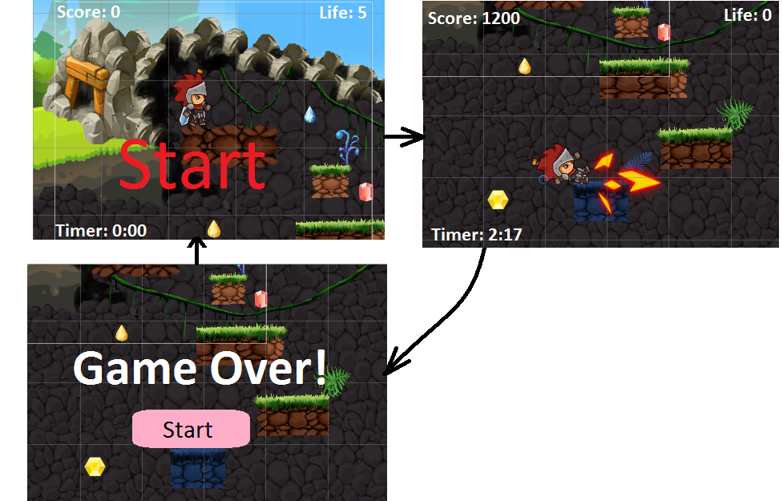

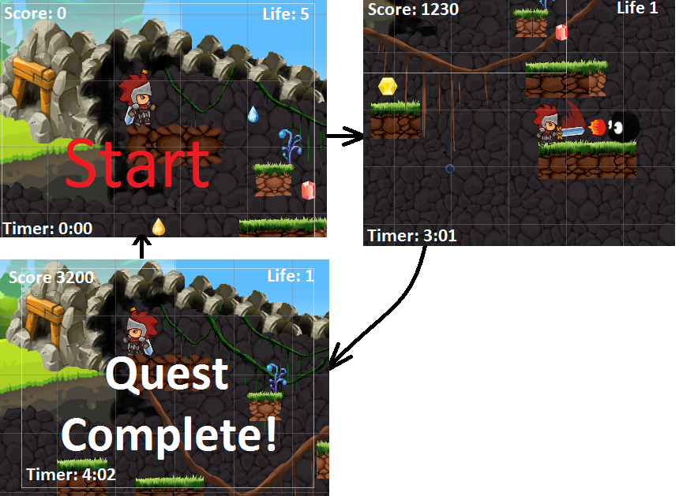

# All assets for your game

| Assets | Image Thumbnail |
| --- | --- |
| Platform Assets: |  |
| Platform Decoration |  |
| Rare Minerals |  |
| Gold Items |  |
| The Mine’s Black Monster |  |
| Grondee (Grr) the Dwarf.  Main Character |  |
| Grr’s fire |  |
| Explosion |  |
| Background Image |  |

# Backstory of the game

## Mine Mine

This is Grondee the dwarf 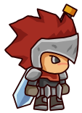, Grr for short. He just inherited his Grandpa’s old mine. It grows some of the richest minerals in the world, but it is also containing some of the most difficult traps of all. The deeper the Grr goes into the mine, the better minerals Grr could get, but worse the traps. But Grr isn’t worried because he has his Grandpa’s journal to walk him through them all, right Grr? 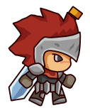noo? ops, oh well, it’s not too late to start a new one.

# Game Mechanics

Use your character’s abilities to overcome game obstacles. Jump to move from platform to platform, and shoot to stun the enemies or destroy blocks.

Collect gold pieces to add pints to your score, getting injured will subtract points from the main character’s health counter. You can earn a set amount of points for picking up the mineral and returning it to the mine entrance.